News- Philadelphia Firefighters, Officers Entertain Hundreds At 57th Annual Hero Thrill Show. September 24, 2011 10:00 PM
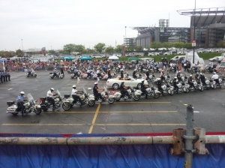 (Credit: Tim Jimenez)
PHILADELPHIA (CBS) – Cloudy skies and a few rain drops didn’t stop many from going to the annual Philadelphia Hero Thrill Show Saturday. The event, in its 57th year, raises money for the education of family members of officers or firefighters hurt or killed in the line of duty.
Many paid to see Philadelphia’s finest perform stunts on motorcycles and show off their emergency equipment, mixed in with games and food.
This year’s grand marshal was actor Burt Young, known for playing “Paulie” in the Rocky movies. He was very emotional meeting with some of the family.
“All I could do was hug them, thank them and cry a little bit.”
One of them was Mindy Maryanowicz. In 1993, her husband officer John Maryanowicz was shot and left paralyzed. Thanks to the show, their son Joseph is now at Holy Family University.
“He is an accountant major and he made the dean’s list last year. It (the scholarship) gives these children an opportunity to do some things that perhaps they wouldn’t be able to do.”
Mindy says even though her husband was hurt years ago, the care for their family never ended.
“My husband’s a hero and no one ever forgets him.”
More than 800 surviving family members have benefited from the event. More than $2 million has been raised since 2001.
Reported by Timothy Jimenez, KYW Newsradio

